<http://www.cs.duke.edu/csed/ap/exams/2004/code/>

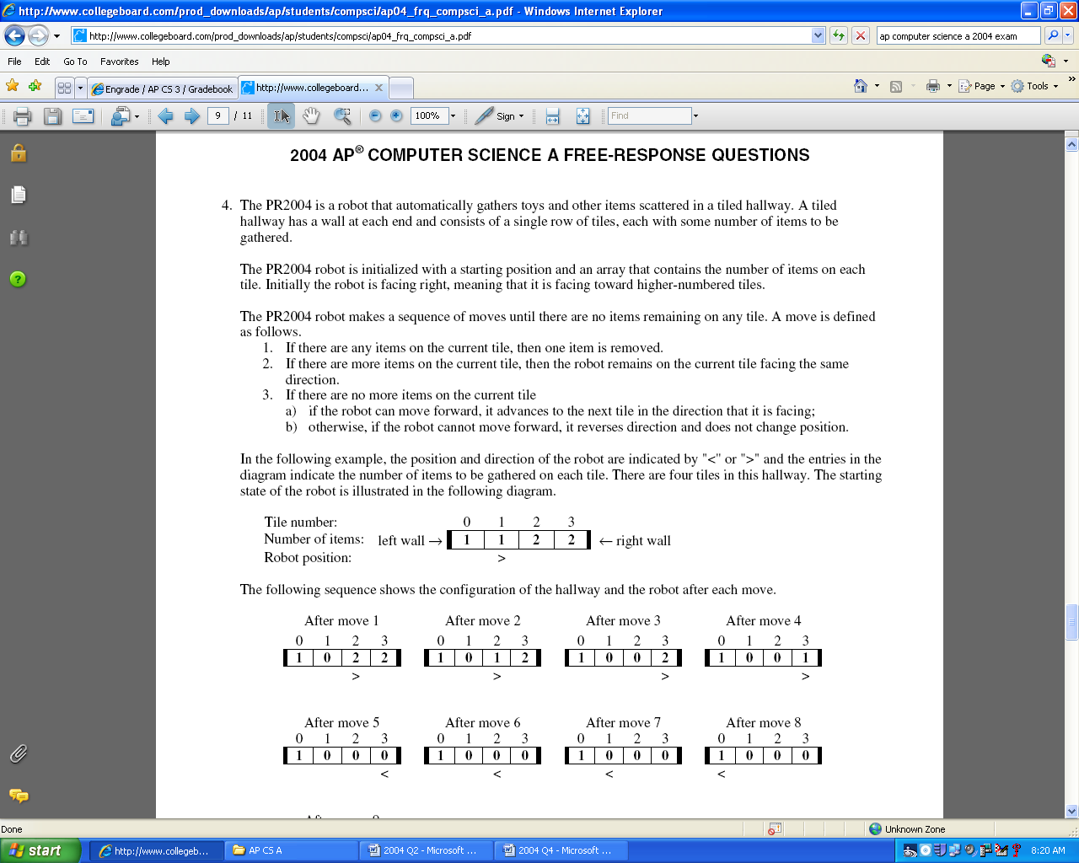

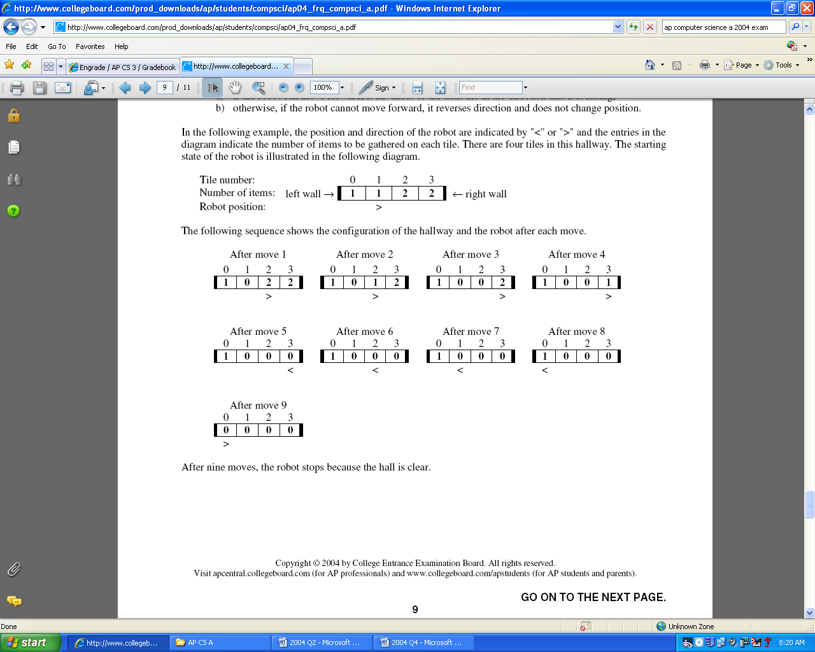

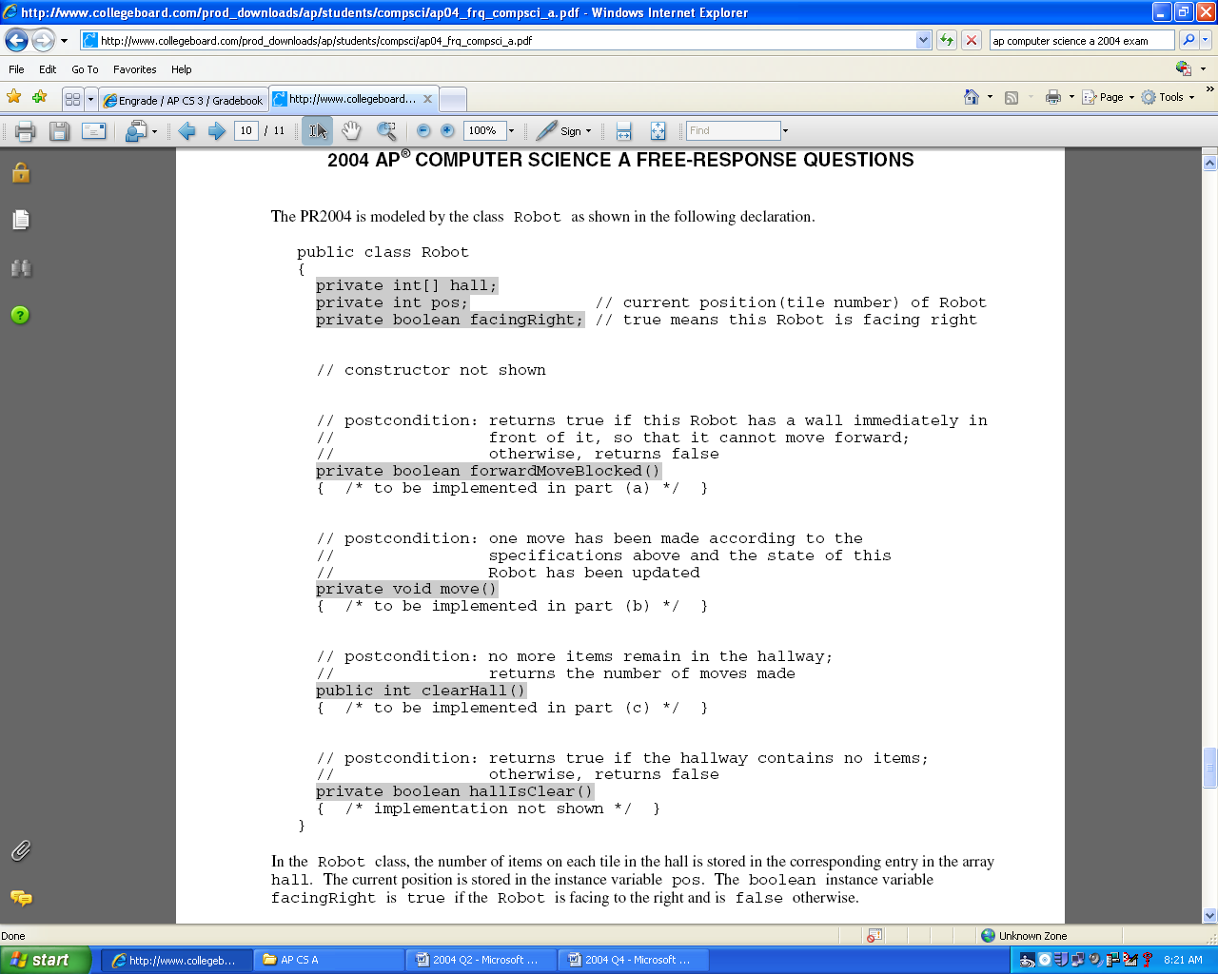

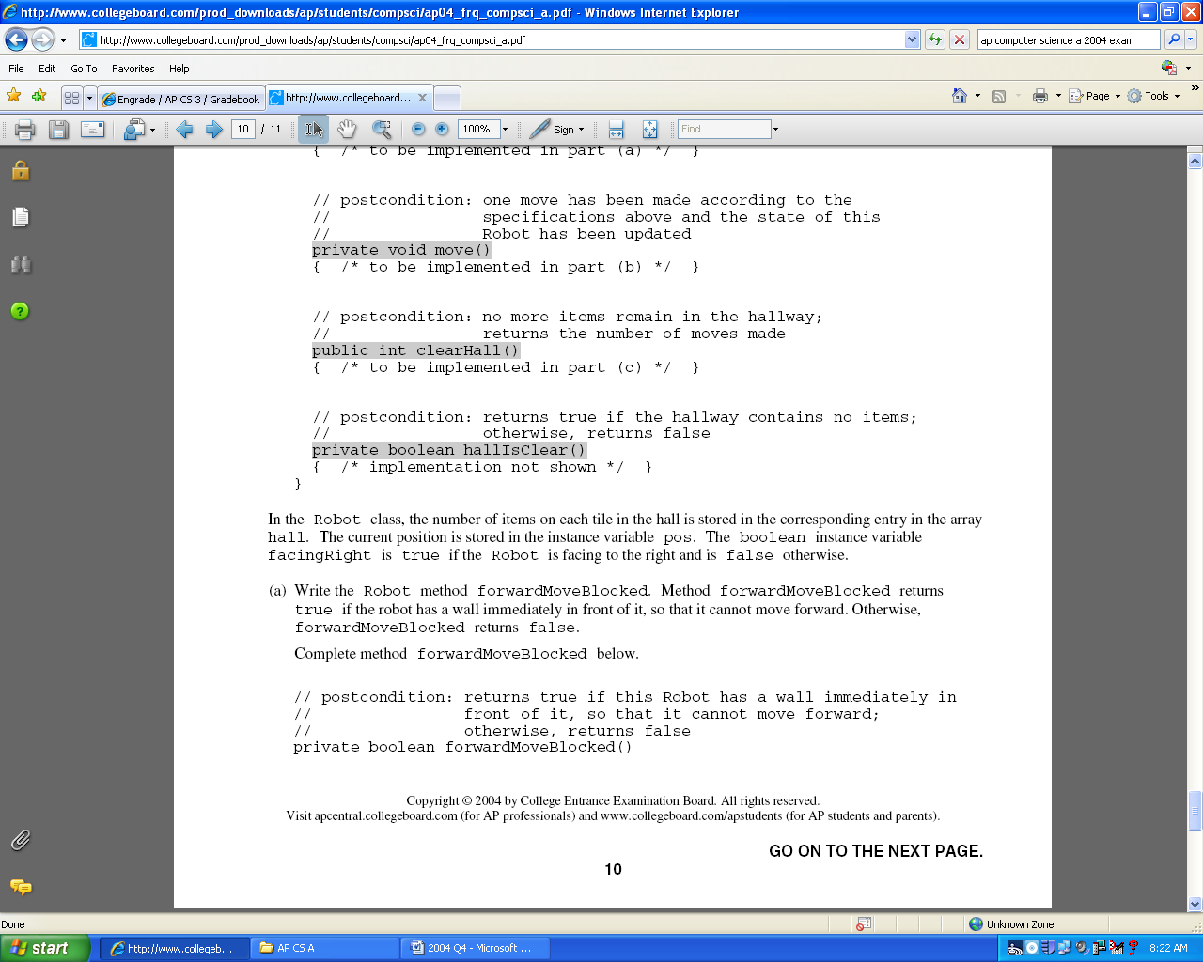

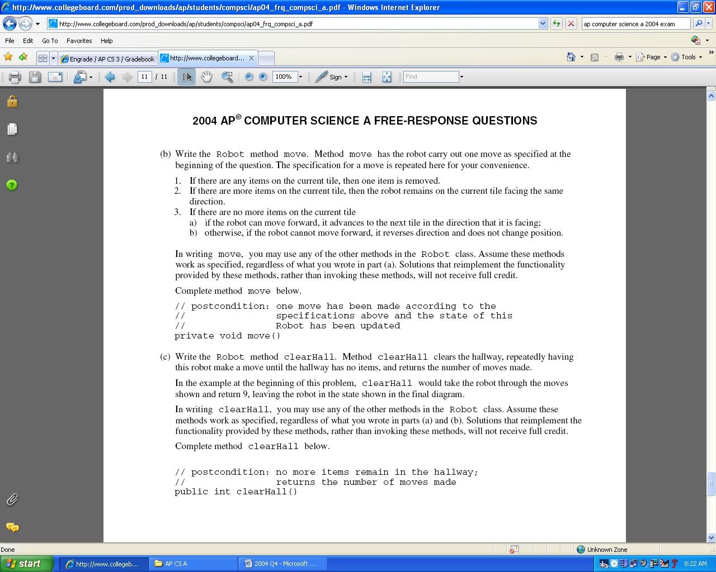

public class Robot

{

private int[] hall;

private int pos;

private boolean facingRight;

private boolean forwardMoveBlocked(){

if (facingRight){

return pos == hall.length-1;

}

else {

return pos == 0;

}

}

private void move(){

if (hall[pos] > 0){

hall[pos]--;

}

if (hall[pos] == 0){

if (forwardMoveBlocked()){

facingRight = !facingRight;

}

else {

// pos += facingRight ? 1 : -1;

if (facingRight){

pos++;

}

else {

pos--;

}

}

}

}

public int clearHall(){

int count = 0;

while (! hallIsClear()){

move();

count++;

}

return count;

}

public boolean hallIsClear(){

return true; // not real

}

}

